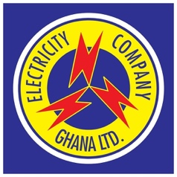2

**Office: Electrovolta House, Ministries, Accra, Ghana**

**ELECTRICITY COMPANY OF GHANA LTD.**

**Managing Director**

**This is to certify ERIC BOAHEN of**

**Nexlink Technologies**

**Accra, Ghana**

**Certificate No. :ECGXL2024070**

**Registration date :**

**Issue Date :**

**Expiry date :**

**ELECTRICAL CONTRACTORS LICENCE**

(EXTERNAL INSTALLATION)

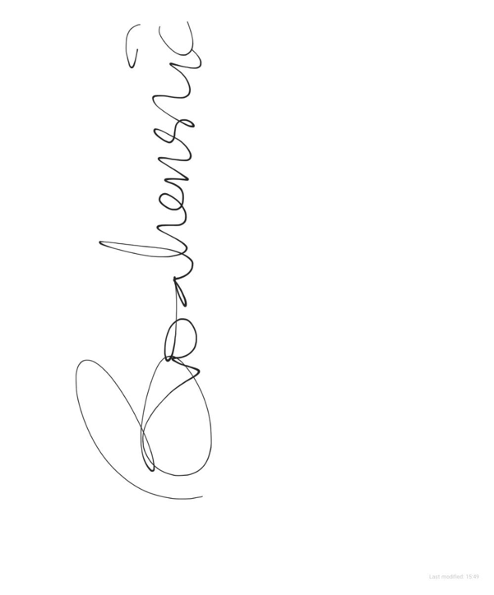

*As a licenced as an Electrical Contractor to*

*carry out external installation under the provision*

*of Electricity Supply and Distribution (Technical*

*and Operational) Rules, 2005 LI 1816*